Edit Menu

By “EDIT” from the “Main Menu”, the user will be presented with a form to enter the reference number of the material they would like to edit as illustrated below.

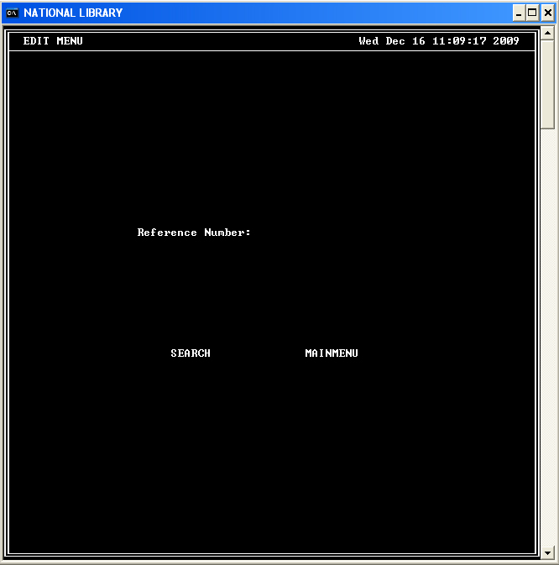

After entering a valid Reference number as shown below:

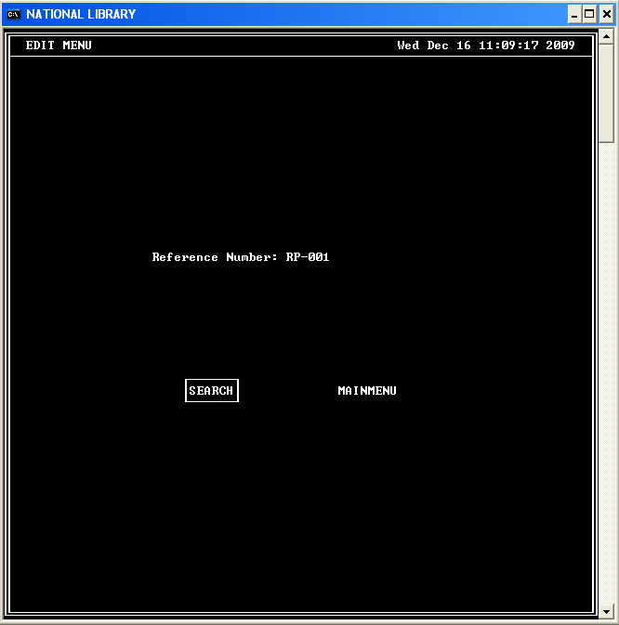

The user will be able to search for the material or return to “Main Menu”.

If the user selects “SEARCH”, if the data is found a screen with a form to edit the information along with the current data stored on the file is displayed.

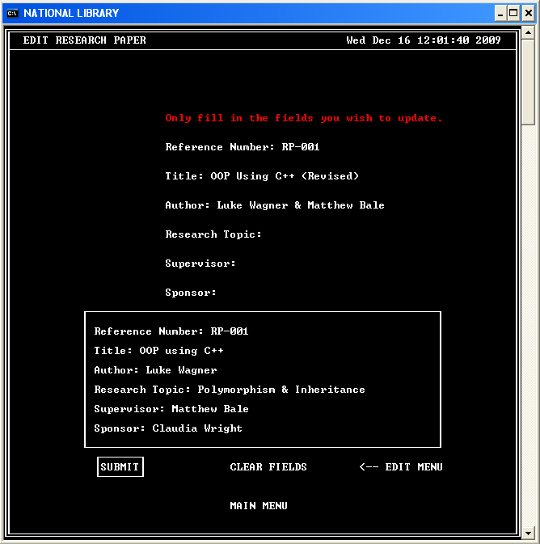

After selecting “SUBMIT”, the user can then confirm the changes or cancel the operation.

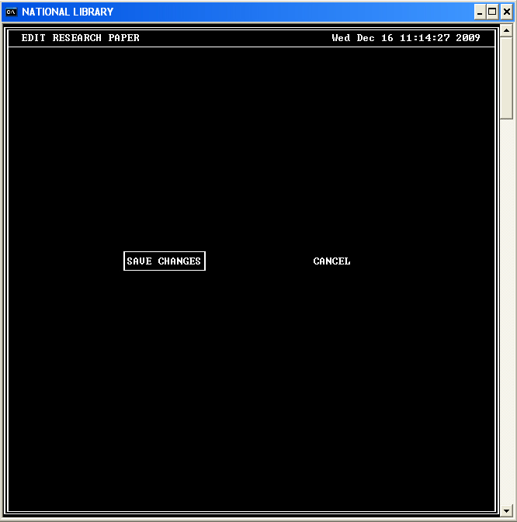

If the user confirms that they want to save the changes, the updated information will be stored and the changes will be displayed to the user.

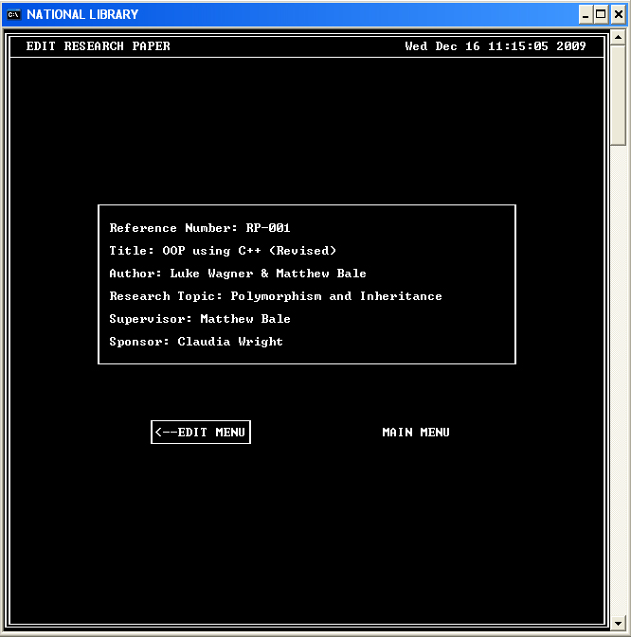

The user can then return to the “Edit Menu” to edit another material or return to the “Main Menu”.

